Scenario
A small cleaning robot starts at position (2, 1) on a 10x10 grid. Its goal is to reach the charging station located at (8, 9). There is a rectangular obstacle that extends from (4, 3) to (7, 6).
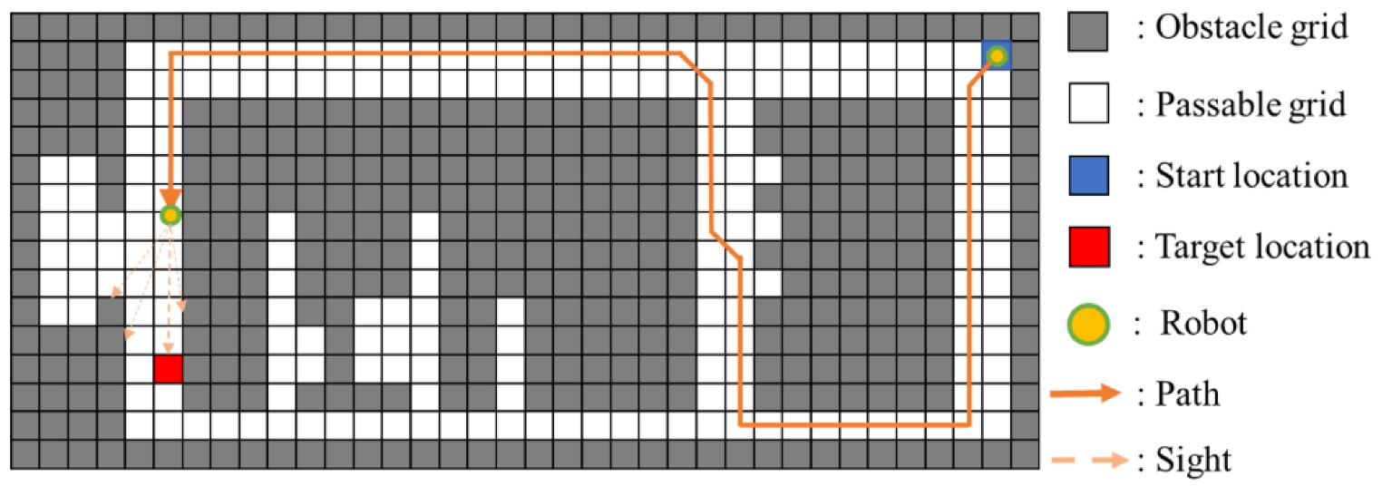

Question
Assuming the robot uses the Bug 2 algorithm and circumnavigates the obstacle in a clockwise direction, calculates the total distance it travels to reach its goal.
Solution
Here's a breakdown of how to calculate the robot's travel distance using Bug 2 and a clockwise circumnavigation:
Moving towards the obstacle:
  - The robot starts at (2, 1) and moves horizontally towards the obstacle until it hits the corner at (4, 3).
  - Distance traveled: 2 units horizontally.
Circumnavigating the obstacle:
  - From (4, 3), it moves down to (7, 3) = 3 units vertically.
  - To the right to (7, 6) = 3 units horizontally.
  - Upwards to (4, 6) = 3 units vertically.
Leaving the obstacle:
  - At (4, 6), the robot has passed its original 'hit point' (4, 3) before returning to the start, meeting the leave condition of Bug 2. It can head directly towards the goal from here.
  - We calculate the distance from (4, 6) to the goal (8, 9) using the distance formula: distance = sqrt(((8-4)^2) + ((9-6)^2)) = 5 units
Total distance:
  - Summing the distances: 2 + 3+3 + 3 + 5 = 16 units

